BGA Void Inspection Report
Quantitative & qualitative void analysis per IPC-A-610 / IPC-7095
Board / image | PCBA2_04.jpg
Report generated | 2026-07-09 19:56
Inspection tool | BGA X-ray Void Inspection Tool
Standards applied | IPC-A-610 / IPC-7095
BGA grid / balls analyzed | 256 expected pads, 256 analyzed
IPC VERDICT: ACCEPT WITH PROCESS INDICATORS
No IPC-A-610 defect. 17 ball(s) in the 10-25% process-indicator band; 1 ball(s) carry one dominant void (IPC-7095 process guidance).

Key void metrics
Average void ratio | 5.2881 %
Median void ratio | 5.3694 %
Worst ball (total void) | 15.2081 %
Worst single void | 12.6416 %
Assessment split | 239 acceptable / 17 process indicator / 0 defect
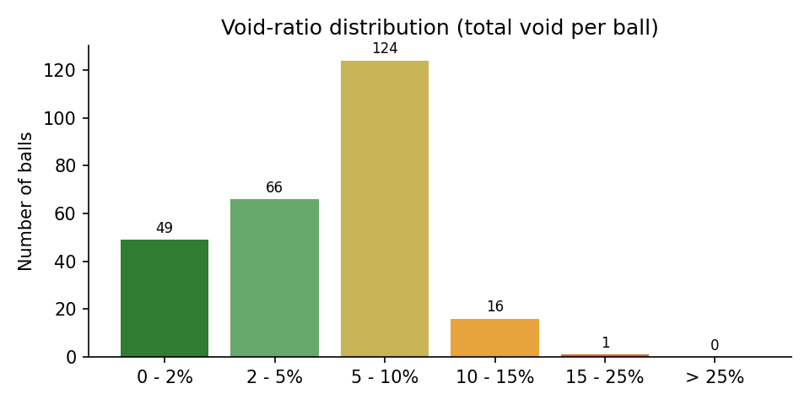

IPC criteria evaluation
Criterion | Source | Limit | Measured | Result
Cumulative void area per ball | IPC-A-610 (Class 1, 2, 3) | <= 25% of ball area | worst ball: 15.21% | PASS
Process indicator band (total void 10-25%) | IPC-7095 process guidance | monitor, not a defect | 17 ball(s) in band | INFO
Largest single void per ball | IPC-7095 (dominant-void guidance) | review above 12.2% area (~35% diameter) | worst single void: 35.6% of ball diameter | INFO
Void location at pad interface | IPC-7095 (30% dia at land) | requires oblique/3D view | not measurable in one top-down 2D X-ray | NOT EVALUATED
Complete ball grid detected | detection integrity gate | all expected pads found | 256 / 256 | PASS

Worst 10 balls by total void
Ball ID | X (px) | Y (px) | Total void (%) | Largest void (%) | IPC assessment
159 | 1757 | 1169 | 15.21 | 11.21 | PROCESS INDICATOR
92 | 1749 | 775 | 14.72 | 6.13 | PROCESS INDICATOR
208 | 2053 | 1467 | 13.33 | 7.41 | PROCESS INDICATOR
203 | 1263 | 1461 | 13.13 | 9.58 | PROCESS INDICATOR
35 | 2141 | 477 | 12.64 | 9.58 | PROCESS INDICATOR
83 | 2143 | 772 | 12.64 | 12.64 | PROCESS INDICATOR
66 | 1848 | 674 | 11.77 | 5.64 | PROCESS INDICATOR
216 | 1459 | 1558 | 11.62 | 7.46 | PROCESS INDICATOR
28 | 770 | 384 | 11.43 | 8.19 | PROCESS INDICATOR
31 | 2043 | 381 | 10.64 | 6.05 | PROCESS INDICATOR

Annotated X-ray (detected voids)
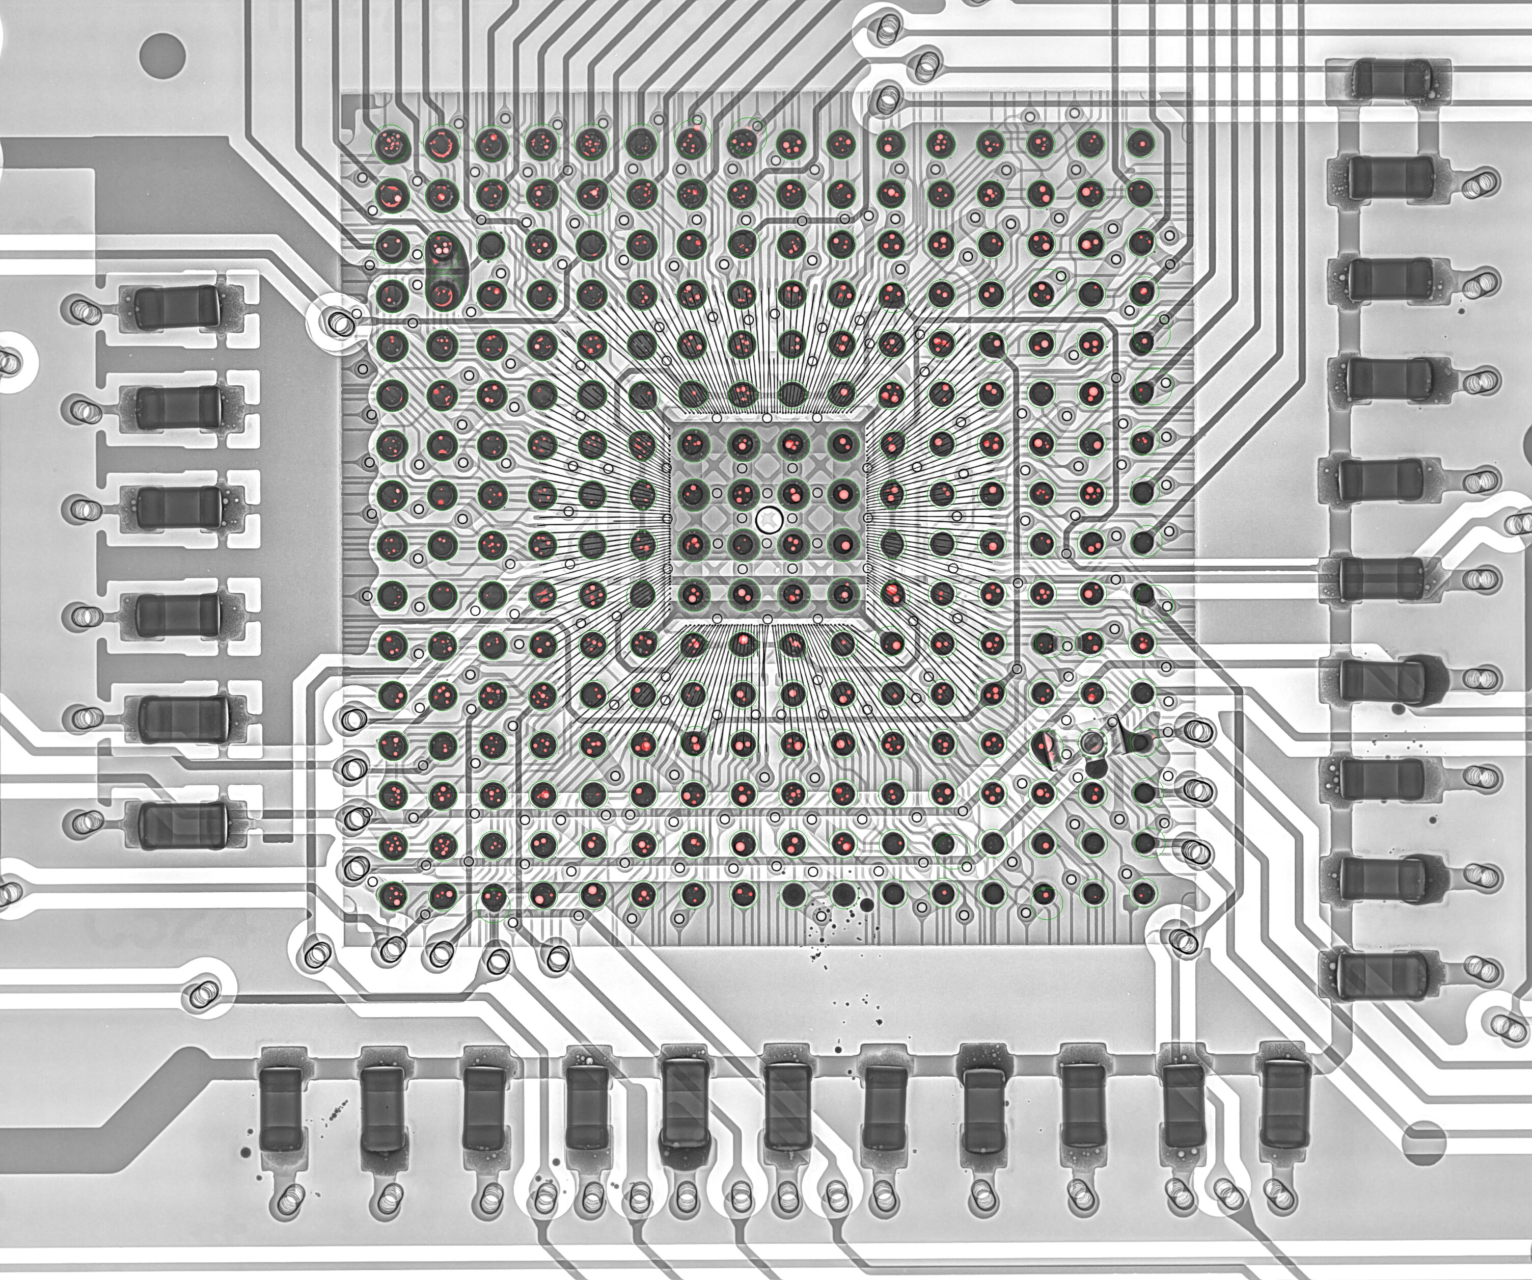

Algorithm analysis - honest assessment

Detection integrity
- Balls detected: 256 of 256 expected grid slots
- Pads placed from grid estimation (no direct evidence): 0
- Mean detection confidence (evidence-backed pads): 1.00
- Ball quality split: 239 PASS / 17 REVIEW / 0 FAIL

Measurement pipeline (what actually produced these numbers)
- 1. CLAHE contrast enhancement + median denoising of the raw X-ray.
- 2. Solder-ball detection: Hough circles + dark-blob evidence, regularized onto the 16x16 BGA grid (affine + homography fit for oblique views, per-ball local snap with non-degradation gates).
- 3. Per-ball void segmentation: median-background subtraction (kernel > ball radius), bond-wire suppression by grayscale closing, residual threshold, then shape filtering.
- 4. Detected void blobs are rendered as fitted circles when they fill >= 45% of the fitted disc (physical voids are spherical gas bubbles); ragged non-circular structures keep their raw contour.
- 5. Component-level sanity filters remove rim arcs, trace stripes, bare-board bleed-through and empty-pad artifacts before metrics.

Classification thresholds applied
- Defect (FAIL): total void >= 25.0% of ball area (IPC-A-610).
- Process indicator (REVIEW): total void >= 10.0% (IPC-7095 guidance).
- Dominant single void (REVIEW): largest void >= 12.25% of ball area (~35% of ball diameter).

Measurement uncertainty - read before trusting decimals
- Projected-area measurement: one top-down 2D X-ray cannot separate package-interface, mid-ball and pad-interface voids; the 25% IPC-A-610 criterion is applied on the projection, exactly as the standard defines it for X-ray inspection.
- Analysis is restricted to the inner 82% of each ball radius; a void hiding exactly on the ball rim can be underestimated.
- Voids smaller than ~10 px^2 (about 0.15% of a ball) are below the detection floor and are intentionally ignored as noise.
- Fitted-circle rendering slightly increases void area versus the raw threshold blob (it includes the faded bubble edge); this is closer to the physical bubble size but adds ~0.3-0.6 percentage points to board averages compared to raw-contour reporting.
- JPEG compression artifacts and CLAHE amplification set a noise floor around 1-2% void ratio; differences below that level are not meaningful.
- On oblique views, perspective foreshortening distorts both ball and void areas; the ratio is partially self-correcting but not perfectly.

Known limitations of this analysis
- Components mounted on the opposite board side project dark shadows between and over balls; the detector anchors circles on grid geometry to resist this, but heavily shadowed balls have reduced void sensitivity.
- Grid slots occupied by vias (no ball populated) are still reported as balls when the slot must be filled; they show ~0% void and near-board brightness.
- Bond-wire suppression (morphological closing) can mask very thin elongated voids lying exactly under a wire.
- The tool measures voiding only; it does not assess head-in-pillow, non-wet opens, bridging or solder-ball shape defects.

Balls to verify manually first (worst 10 by total void)
- Ball #159 at (1757, 1169): total 15.21%, largest single 11.21% -> PROCESS INDICATOR
- Ball # 92 at (1749, 775): total 14.72%, largest single 6.13% -> PROCESS INDICATOR
- Ball #208 at (2053, 1467): total 13.33%, largest single 7.41% -> PROCESS INDICATOR
- Ball #203 at (1263, 1461): total 13.13%, largest single 9.58% -> PROCESS INDICATOR
- Ball # 35 at (2141, 477): total 12.64%, largest single 9.58% -> PROCESS INDICATOR
- Ball # 83 at (2143, 772): total 12.64%, largest single 12.64% -> PROCESS INDICATOR
- Ball # 66 at (1848, 674): total 11.77%, largest single 5.64% -> PROCESS INDICATOR
- Ball #216 at (1459, 1558): total 11.62%, largest single 7.46% -> PROCESS INDICATOR
- Ball # 28 at (770, 384): total 11.43%, largest single 8.19% -> PROCESS INDICATOR
- Ball # 31 at (2043, 381): total 10.64%, largest single 6.05% -> PROCESS INDICATOR

Grid-estimated pads (verify visually)
- None - every pad was detected from direct image evidence.
Generated automatically by BGA X-ray Void Inspection Tool on 2026-07-09 19:56. Verdicts follow IPC-A-610 (25% cumulative projected void area per ball) with IPC-7095 process guidance; they are based on a single top-down 2D X-ray projection and should be confirmed by an operator for boards flagged REVIEW or REJECT.

